User Manual
Custom Report Upload

JobCTRL 

Dear User!

Requirement note: You have to access to the ’serverHost’ where the JC360 program works. In the text below you can found ’CustomReport’ names what you should rename with your filename without ’.cs’ extension. This document and it’s pictures content are created to the JC360 website version V363 (2021-01-20).

To able to use ’CustomReport’ report, do the following steps:
- Copy the ’CustomReport.cs’file to the ReportTemplates folder what's path is the '\JobCTRL_Website\ReportTemplates'.
- Go to the ’ Custom report definitions’website: '{serverHostName}/UserCenter/DataCollectorDefinitions.aspx'. Note: The pictures from 1 to 4 what contain the actual screenshot from the site.
- Then fill the name and description fields with arbitary value (on the Picture 1 points 1-2)
- 'Data collection keys' field must be the followings (on the Picture 1 point 3) emailfrom;emailto;emailtype;filename;filepath;IsActive;IsInOffice;ProcessName;subject;Title;Url
- 'Querying data for the local periods of queried users' check this box (on the Picture 1 point 4)
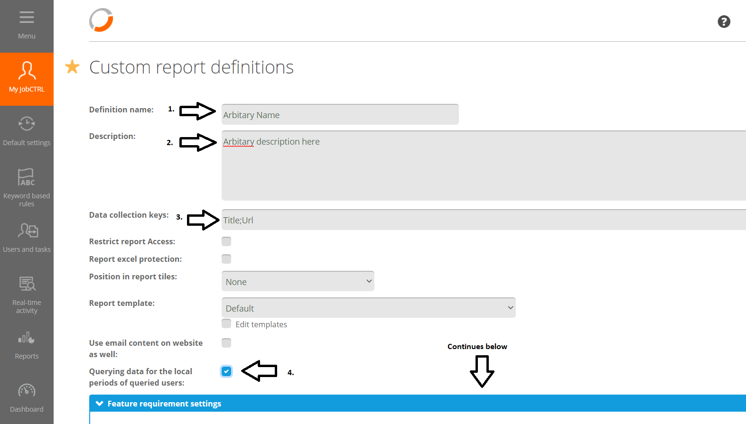

Picture 1
- 'Feature requirement settings' select the following checkboxs and sliders (on the Picture 2 point 1):
  - Others' column (on the Picture 2 point 2): Tup generation, Productivity categories, Computer activity
  - Users' column (on the Picture 2 point 3): Mobile phone calls, Daily schedules, Work time settings, Leaves, System settings
  - Task' column (on the Picture 2 point 4): TUP Realated (To see ’ TUP Realated’ button, you have to check Tup generation in the ’others’ column
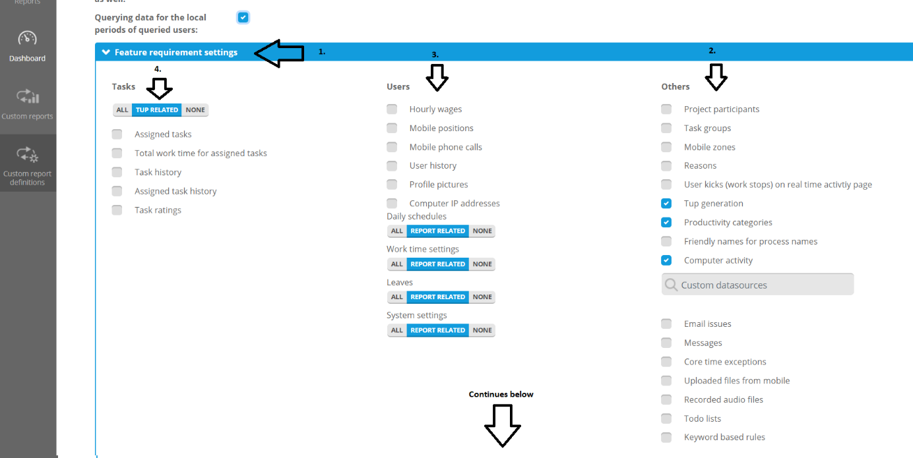

Picture 2
- Delete the text from HTML format area (on the Picture 3 point 1).
- Insert the following code (what is below in the grey area box), to the "Processing script (c#)" area (on the Picture 3 point 2):
Note: The path of the ’CustomReport.cs’ file on the given {serverHostName}, so where you placed the ’CustomReport.cs’ file in the step (1).
//#LOAD "CustomReport.cs"
public void Execute()
{
var report = new CustomReports.CustomReport(this);
report.Execute();
}
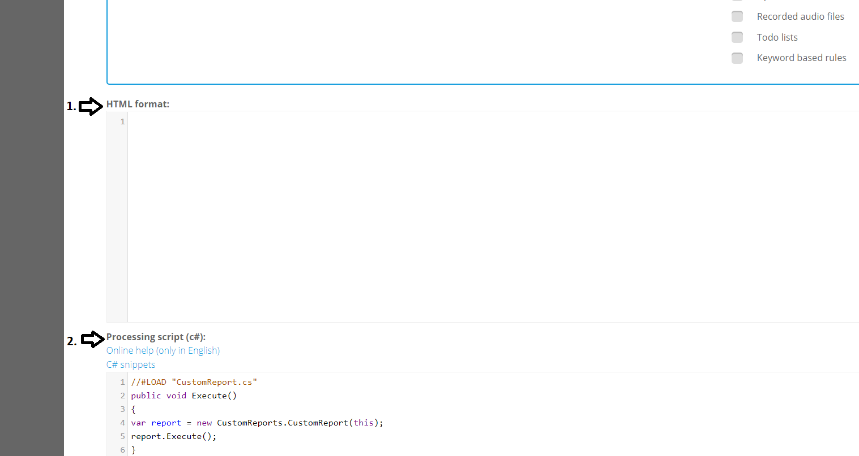

Picture 3
- Click on the Create button (on the Picture 4 point 1).
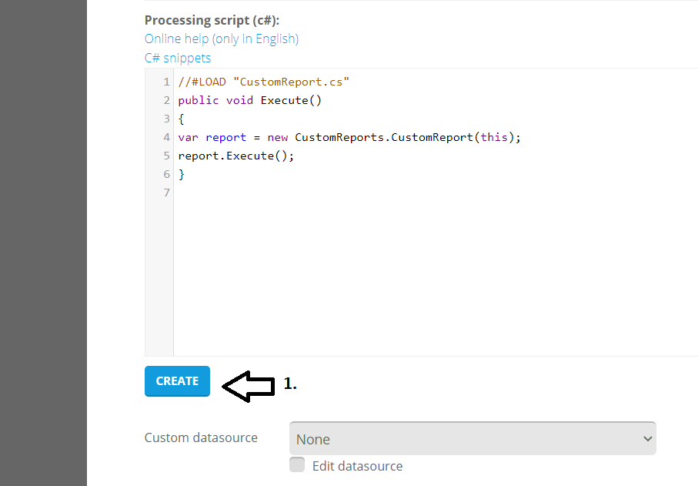

Picture 4

- After the steps from 1 to 9 are done, then you are able to use the report on the following ’Custom reports’ website: '{serverHostName}/UserCenter/Reports/DataCollectorReport.aspx'.
Note: If you never do it before then you do step by step the following poins from (a) to (e). If you did it earlier then do only the point (b).
  - Choose an arbitary ’Period’ (on the Picture 5 point 1)
  - Select the previously (step 3) named report from the ’Definition name’ (on the Picture 5 point 2)
  - Choose ’users/groups’ (on the Picture 5 point 3)
  - Click the filter icon to ’filter user hierarchy’ (on the Picture 5 point 4)
  - Click on the ’Download (XLSM) button (on the Picture 5 point 5) to donwload the CompanyReport report.
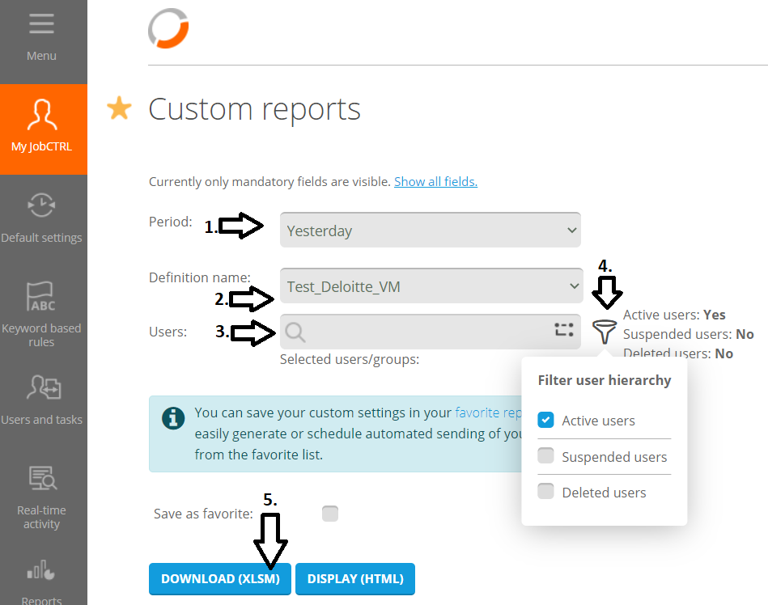

Picture 5

